

Purbanchal University
College of Information Technology and Engineering
Tinkune, Kathmandu

PROJECT REPORT
On
BIT – I PROJECT
Library Management system
Submitted To:
Department Science and technology
Submitted By:
Santosh Adhikari (313272)
Bikesh Khyaju (313261)
Sujan Subedi (313274)
Batch: 2020
Faculty: Science and technology
Program: Bachelor of information technology

Date of submission:

ACKNOWLEDGMENT

We would like to express our gratitude and appreciation and present “Library Management System” report with as part of curriculum “Bachelor of information Technology”. We wish to thank all the people who gave us unending support.
We express our profound thanks to our IT Head of Director (HOD) Mr. Bhanu Niroula, Project Supervisor Mr. Kamal Bahadur Rana and all those who have indirectly guided and helped us in preparation of this project.
We would also like to thank College of Information Technology and Engineering for the course and the project assigned which helped in our study.

ABSTRACT

Library Management System is designed for Library to manage library information faster and easier. This program will be used in library front desk to keep record of the books, library members, students.
Library is place where all kind of books are available. This library management system is mainly used by Liberian and library admin. Library management system is a project which aims in developing a computerized system to maintain all the daily work of library. This project has many features which are generally not available in normal library management systems like facility of admin login through which the admin can monitor the whole system of user login. Library management system which mainly focuses on basic operations in a library like adding new member, new books, and updating new information, searching books and members and facility to borrow and return books.
It has included system planning, requirement analysis, system design, programming, system testing, and evaluation of project. Overall, this project of ours is being developed to help the students as well as staff of library to maintain the library in the best way possible and also reduce the human efforts.

TABLE OF CONTENTS
ACKNOWLEDGMENT i
ABSTRACT ii
INTRODUCTION 1
1.1 Introduction 1
1.2 Proposed System 1
1.3 Objective 2
1.4 Features 2
1.5 Problem statement 2
1.6 Aim for this application 2
SYSTEM SPECIFICATION 3
3.1 Tools and Technologies 3
3.2 Software Developed at 3
3.3 Team Structure 3
3.4 Implementation plan 4
3.5 Implementation Detail 4
3.6 File Structure 5
3.7 File Handling 5
3.8 String Function 5
SOFTWARE DESIGN AND DEVELOPMENT 6
4.1 System Interface: 6
4.1.1 Select Screen 6
4.1.2 Admin Login Screen 6
4.1.3 Student Login Screen 6
4.1.4 Admin Dashboard Screen 6
4.1.5 Student Dashboard Screen 6
4.1.6 Booklist Screen 6
4.2 Flow chart: 7
4.2 Gantt chart: 8
TESTING 9
CONCLUSION & FURTHER WORKS 10
6.1 Conclusion: 10
6.2 Further works: 10
REFERENCES 11
APPENDIX 12
1. Welcome Screen 12
2. Main menu Screen 12
3. Admin Screen 13
3.1 Admin login 13
3.2 Admin panel 13

INTRODUCTION

1.1 Introduction
Computer programming and applications are very important in our daily life. As they make our life and our work easy and systematic. So, in today’s challenging world, every system is developed and lunched with the concept of betterment and improvement. Library Management system is also developed with same concept of making Library management much faster and easier.
A Library Management System is software built to handle the primary housekeeping functions of a library. Libraries rely on library management systems to manage data and information of its members. Library management systems help libraries keep track of the books and their details. As students, staffs and books are all related terms of the libraries, there should be proper way of management in Library Management system. The records of the students, books and staffs should be kept and should be known to the authorized people only. The Library Management system should be easy to work with and fast. To have a better management program it should be easy to add, search, view, modify and to delete, it should be less time consuming.

1.2 Proposed System
This application will be extremely beneficial for the libraries intending to use for managing records which will help in knowing books information and helps to know the daily information like books borrowed, book returned, students’ info.
“Library Management System”, is a simple application, which seeks to help the library to improve its current system. The project is basically aimed at providing a detailed and complete information about the number of books in library.

1.3 Objective
Following are the objectives behind the system
- To provide statistical records.
- To make data entry of students and books easy and fast.
- To maintain the records without consuming much time and effort.
- To make it easier for the librarian or authorized person to check the record of student, staffs and books for future use.
- To keep track of every book and their check-outs and return times.

Features
- It is useful for keeping records of numbers of the books.
- It is useful to know which books are available.
- Books can be added and removed.

1.5 Problem Statement
- Valuable time wasted from inconvenient and less efficient ways of recording.
- Paper is used for recording books add students’ information.

1.6 Aim for this application
The project “Library Management System” includes the following functionalities:
- To provide easy to use application.
- To eliminate the paper work in library.
- Faster performance.
- To store data for further use.

SYSTEM SPECIFICATION

3.1 Tools and Technologies
This project is designed in dev c and Visual Studio code. The project uses GCC compiler. The coding is stored in .c and .h file extension.

3.2 Software Developed at
Operating System: Windows 10
Developing software: Visual Studio code, dev c/c++
Processor: intel core i3
Memory: 8 GB RAM
Hard disk: 520 GB[SSD]

3.3 Team Structure

Team Members | Symbol no. | Task Done
Santosh Adhikari | 313272 | Research, Coding, Debugging and Documentation
Bikesh Khyaju | 313261 | Research, Coding, Debugging and Documentation
Sujan Subedi | 313274 | Research, Coding, Debugging and Documentation

Table no. 1:

3.4 Implementation plan
We have used following header file:
Header file | Library function | Description
ADMIN  - admain.h  - acount.h  - admreg.h | ad_main()  acc()  admin_register() | These is the header file of the dmin panel.
STUDENT  - student.h  - stumain.h | student_login()  stu_chose() | These is the header file of the student panel.
book.h | book_main() | These is the header file of the book details.
login.h | admin_ligin()  user_exists() | These is the header file for admin login, check admin, register admin
Table no. 2

3.5 Implementation Detail
The function used in the program as to maintain the program simpler and make a better program structure and work with team members.

main() | Welcome screen is shown
ch_menu() | 4 choice is shown in the screen for admin, student, book, exit
admin_login()  student_login() | Login screen ask for username and password.
ad_main() | Admin panel first screen to choose an option
acc() | Manage Admin records
stu_chose() | Student panel first screen to choose an option
book_main() | Book panel first screen to choose an option
Table no. 3

3.6 File Structure
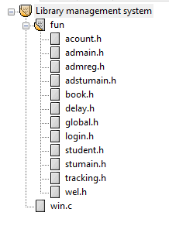
File management was taken into consideration while developing this project. Different source and header files are used according to their use/functionality in program. This process of working with different files makes development process easier while working in the group.

3.7 File Handling
File handling is used in this program in order to save books data and admin & students data in the file. book information like book name, author name and number of books available is saved in a file so that once book info is uploaded on the system user can view them. The admin and student information are also stored on the file.

3.7 String Function
String functions are used in this program for string variables. In this program string function like strcmp (), strcpy () and strstr () are used.
Strcmp () – This function is used to campier the string like password, name.
Strcpy () – This function is used to copy a string from a variable to another.

Software Design and Development

4.1 System Interface:

4.1.1 Select Screen
The select screen contains of information of the next screen. This window shows choice admin login, student login and exit to user. After looking at the detail’s users can type 1, 2 or 3 button to select an option. After selection now new window appears where user can login or quit program.

4.1.2 Admin Login Screen
In this screen the admin enters their username and password in order to access the dashboard panel.

4.1.2 student login Screen
In this screen the students are to enter their username and password in order to access the dashboard panel.

4.1.4 Admin Dashboard Screen
This screen allows the admin user to add new books and also view old books data. Admin can enter books name from file. Then the data entered by the admin is saved in file and updated to the main screen.

4.1.5 Student Dashboard Screen
This screen allows the student user to browse books and view books information. Students can search books with Id or name from file.

4.1.6 Books list Screen
This screen displays all the books with their information stored by admin in booklist.txt file.

4.2 Flowchart:
3
1
WELCOME
START
ch_menu 1/2/3/4

4

ENTER Username & Password

ENTER Username & Password

Check Login details
Book Details
ADMIN
STUDENT
BOOK
Check Login details
2
STOP
Y
Admin Panel 1. book management 2. Student manages. 3. Admin Account
Student panel
Admin register
Y
N
N

4.3 GANTT Chart

TESTING

Testing in a project development is a very important task to find out the possible mistakes made by the developers. The system cannot give the correct output until the project contains no errors at all. This project has checked the possible errors by step by step checking every functions. We have also check for bugs in this program by entering data in program and checking if data is displayed in screen. We have checked line by line every code for errors.

CONCLUSION & FURTHER WORKS

6.1 Conclusion
This is a system for library to use in order to manage their book records. With the help of this program, we can store book records, admin information, student information, manage student information and so on.

6.2 Further work
This is our first C program; the program lacks many logical and technical features that could be improved. Some of the ideas have made the code more efficient and would help the users. Similarly, some features of the program may be troublesome for some users. However, in spite of the drawbacks the code runs well and all these drawbacks can be easily dealt with, with further understanding of C. We also have planned to add some extra features in the coming days, so that we can make the program more efficient and reliable.

REFERENCES

https://github.com/RanaBKamal/bitprojecti
https://aticleworld.com/library-management-system-project-in-c/

APPENDIX

Welcome screen

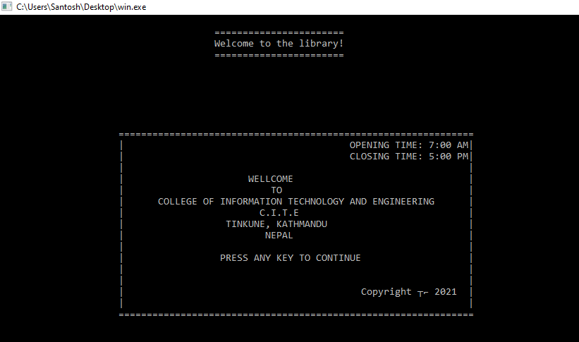

Main menu screen
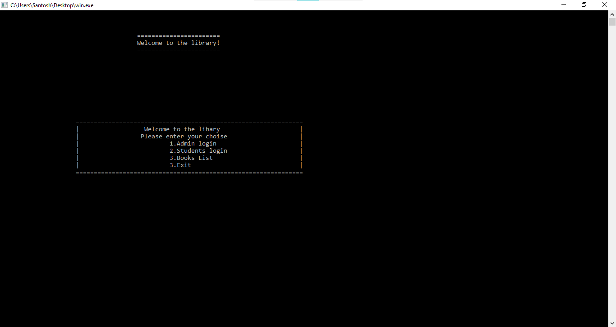

Admin screen

3.1 Admin Login
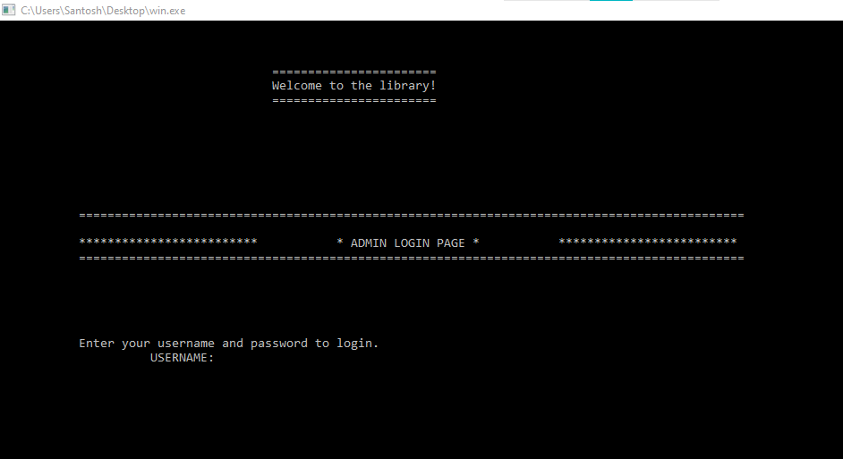

3.2 Admin panel
